**Use Case Diagram**

|  |  |
| --- | --- |
| **Symbol** | **Name** |
| 🛉 | Actor |
|  | Use Case |
| ⸏ | Connector |
| ⟶ | Generalization |
| ⇢ | Stereotype |

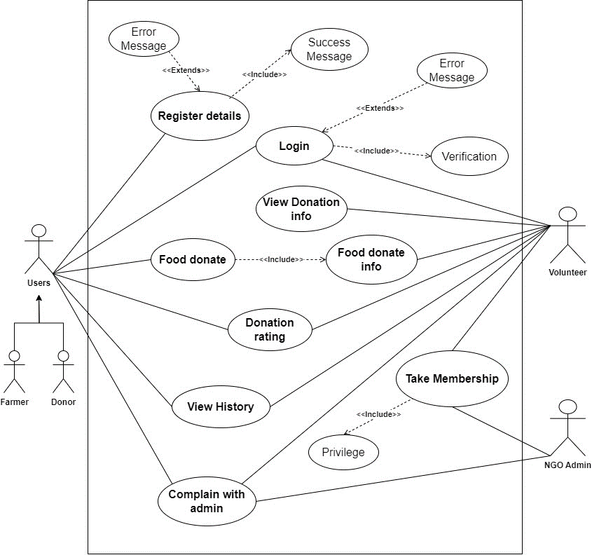

**High-Level Use Case**

**Register**

|  |  |
| --- | --- |
| **Use Case:** | Register Details |
| **Actors:** | Donor, Volunteer, NGO, Farmer |
| **Descriptions:** | All users can input their respective details into the system. Upon submission, the system automatically registers the provided information, ensuring seamless integration and efficient data management. |

|  |  |
| --- | --- |
| **Use Case:** | Success Message |
| **Actors:** | Donor, Volunteer, Farmer |
| **Descriptions:** | The user can provide the details and go to register if it is valid then show the successful message. |

|  |  |
| --- | --- |
| **Use Case:** | Error Message |
| **Actors:** | Donor, Volunteer, Farmer |
| **Descriptions:** | The user can provide the details and go to register if it is not valid then show the error message. |

**Take Membership**

|  |  |
| --- | --- |
| **Use Case:** | Take Membership |
| **Actors:** | Volunteer, NGO |
| **Descriptions:** | A new volunteer provides the personal details, and his/her details are registered with the system. The NGO provide the membership then volunteers take the new membership. |

|  |  |
| --- | --- |
| **Use Case:** | Privilege |
| **Actors:** | Volunteer |
| **Descriptions:** | After taking a new member, a new volunteer gets the privilege of the food donation system. |

**Login**

|  |  |
| --- | --- |
| **Use Case:** | Login |
| **Actors:** | Donor, Volunteer, Farmer |
| **Descriptions:** | After registering details in the system, all the users can provide valid details and log in to the system Then successfully log in to the system. |

|  |  |
| --- | --- |
| **Use Case:** | Verification |
| **Actors:** | Donor, Volunteer, Farmer |
| **Descriptions:** | A new user-provided login details are checked in the database where it is registered or not registered in the system. If its details are registered, then verify to give the login access in the system. |

|  |  |
| --- | --- |
| **Use Case:** | Error Message |
| **Actors:** | Donor, Volunteer, Farmer |
| **Descriptions:** | If the user login details are not registered or invalid, then the system shows the error message. |

**Food Donate**

|  |  |
| --- | --- |
| **Use Case:** | Food Donate |
| **Actors:** | Donor, Farmer |
| **Descriptions:** | The Donor or Farmer can donate the proper food information and details with location. The system can show the donation food details in the history after posting the donated food. |

|  |  |
| --- | --- |
| **Use Case:** | Food Donate Information |
| **Actors:** | Donor, Farmer, Volunteer |
| **Descriptions:** | When a donor donates food posted in the system all the volunteers can get the donation information (Notification). |

**View Donation info**

|  |  |
| --- | --- |
| **Use Case:** | Donation Rating |
| **Actors:** | Volunteer |
| **Descriptions:** | After receiving the donation info, the volunteer can view the donation details if it is possible or not possible to distribute. |

**Donation Rating**

|  |  |
| --- | --- |
| **Use Case:** | Donation Rating |
| **Actors:** | Volunteer, Donor |
| **Descriptions:** | After the food is completely donated to some people the volunteer can give the donation rating to the donor with food distributed information. |

**View History**

|  |  |
| --- | --- |
| **Use Case:** | View History |
| **Actors:** | Donor, Volunteer, NGO, Farmer |
| **Descriptions:** | All the users can view the history of food donation where who donate, where to donate or more details. |

**Complain with Administration**

|  |  |
| --- | --- |
| **Use Case:** | Complain with Admin |
| **Actors:** | Donor, Volunteer, Admin |
| **Descriptions:** | After contact with donors and volunteers the donors cannot be provided or donate food and the receiver cannot come to receive the donation food, they can complain to the admin |

**Expanded Use Case**

|  |  |  |
| --- | --- | --- |
| **Use Case:** | Register Details | |
| **Actors:** | Donor, Volunteer, NGO, Farmer | |
| **Descriptions:** | All users can input their respective details into the system. Upon submission, the system automatically registers the provided information, ensuring seamless integration and efficient data management. | |
| Typical Courses of Events: | | |
| **Donor, Volunteer, NGO, Farmer** | | **System Response** |
| 1. A new user can provide the personal details for the register in the system. | |  |
|  | | 2. The system checks whether the provided details are valid or not valid. |
| 3. Request for register in the system. | |  |
|  | | 4. Conform register with a success message if no valid data, then show the error message. |

|  |  |  |
| --- | --- | --- |
| **Use Case:** | Take Membership | |
| **Actors:** | Volunteer, NGO | |
| **Descriptions:** | A new volunteer provides the personal details, and his/her details are registered with the system. The NGO provide the membership then volunteers take the new membership. | |
| Typical Courses of Events: | | |
| **Volunteer, NGO** | | **System Response** |
| 1. A new volunteer can provide the personal details for the registered membership in the NGO. | |  |
|  | | 2. Check the Volunteer details. |
| 3. Request to take membership in the NGO. | |  |
|  | | 4. Confirm the registered membership and give the privilege. |

|  |  |  |
| --- | --- | --- |
| **Use Case:** | Login | |
| **Actors:** | Donor, Volunteer, Farmer | |
| **Descriptions:** | After registering details in the system, all the users can provide valid details and log in to the system Then successfully log in to the system. | |
| Typical Courses of Events: | | |
| **Donor, Volunteer, Farmer** | | **System Response** |
| 1. A new user can provide the login details in the system. | |  |
|  | | 2. The system checks whether the provided details are valid or not. |
| 3. Request for login in the system. | |  |
|  | | 4. The system can navigate to the dashboard if valid data is provided to log otherwise shows the error message. |

|  |  |  |
| --- | --- | --- |
| **Use Case:** | Food Donation | |
| **Actors:** | Donor, Farmer, volunteers | |
| **Descriptions:** | The Donor or Farmer can donate the proper food information and details with location. The system can show the donation food details in the history after posting the donated food. | |
| Typical Courses of Events: | | |
| **Donor, Farmer** | | **Volunteers** |
| 1. A donor can post the food details for donation. | |  |
|  | | 2. After getting the donation information volunteers respond to the request to accept the food. |
| 3. Donors confirm to provide the food when contacted with the donor. | |  |
|  | | 4. Volunteers receive the food and go to distribute it. |

|  |  |  |
| --- | --- | --- |
| **Use Case:** | View Donation Info | |
| **Actors:** | Volunteers | |
| **Descriptions:** | All users can input their respective details into the system. Upon submission, the system automatically registers the provided information, ensuring seamless integration and efficient data management. | |
| Typical Courses of Events: | | |
| **Volunteer** | | **System Response** |
| 1. A volunteer can view the donation post food details. | |  |
|  | | 2. show the donation food details with all information like food info, donor info and location details. |
| 3. View the donated location. | |  |
|  | | 4. The system can show the food donated location with Google Maps. |

|  |  |  |
| --- | --- | --- |
| **Use Case:** | Donation Rating | |
| **Actors:** | Donor, Volunteer, Farmer | |
| **Descriptions:** | After the food is completely donated to some people the volunteer can give the donation rating to the donor with food distributed information. | |
| Typical Courses of Events: | | |
| **Volunteer, Farmer** | | **Donor** |
| 1. After the food received to distributed give the donation rating with all the information. | |  |
|  | | 2. Get the donated rating info. |
| 3. Not possible to accept the donation of food if the volunteer cannot give a response. | |  |
|  | | 4. Volunteers do not respond to receive the food and when the expiration date is over the donor gets the expiration notification. |

|  |  |  |
| --- | --- | --- |
| **Use Case:** | Complain with Admin | |
| **Actors:** | Donor, Volunteer, Farmer | |
| **Descriptions:** | All users can input their respective details into the system. Upon submission, the system automatically registers the provided information, ensuring seamless integration and efficient data management. | |
| Typical Courses of Events: | | |
| **Donor, Volunteer, Farmer** | | **Admin Response** |
| 1. The food donation time donor volunteer and farmer can complain to the admin. | |  |
|  | | 2. Admin verifies the complaint. |
| 3. Request for succession. | |  |
|  | | 4. Admin gives the warning. |
| 5. Received warning. | |  |

**Context Diagram**

**Data Flow Diagram (DFD)**

**Class Diagram**

**Activity Diagram**

**Entity Relationship Diagram (ERD)**

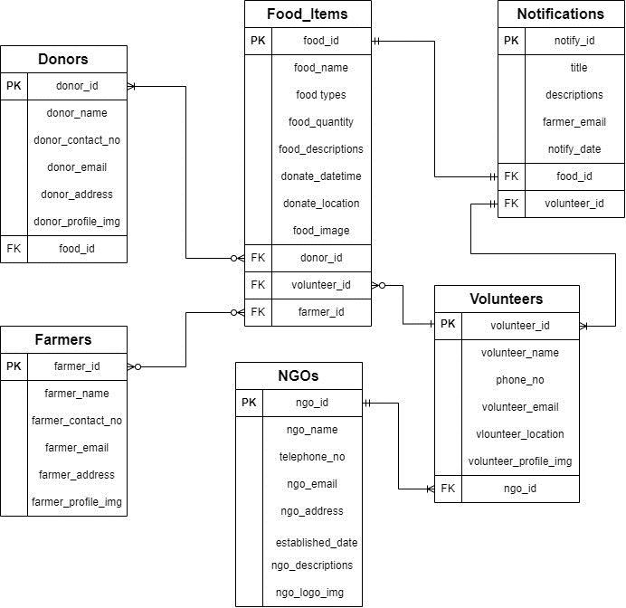

**System Architecture**

**Wireframe**